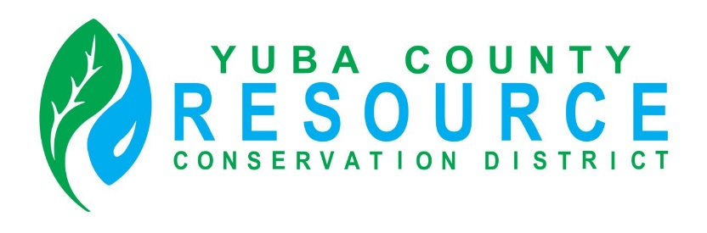
Yuba County Resource Conservation District
Banking and Expense Reimbursement Policy

Revision Adopted:
PURPOSE
The purpose of this Banking Policy is to provide a guide to the Yuba County Resource Conservation District (District) decision making with regard to financial activities and finance related operations; and to ensure transparency in operations for the Board of Directors and the public.
General Directives
- The Board Treasurer with the approval of the Board President has the authority to open or close a bank account.
- The Board will review banking transactions at each Board meeting monthly.
- The bank account and debit card will be used for authorized transactions only (no personal use).
- Checks over $500 will require two signatures.
- Board members or staff may use debit cards to purchase office supplies/software, etc. under $100; over $100 will require prior authorization from the Board or Board President.
Reimbursement of Actual and Necessary Expenses
The Yuba County Resource Conservation District shall reimburse Directors and Staff for the actual and necessary expenses incurred in the performance of their official duties. This shall include but is not limited to:
- Registration costs for educational training and conferences (training/conferences held outside the State will require approval by the Board)
- Meetings or office visits of a substantial duration concerning substantive District business as requested by the Board President
- Mileage (actual mileage will be reimbursed at the Standard IRS Mileage Reimbursement Rate)
Directors/Staff will be reimbursed for actual expenses incurred while participating in conferences, trainings, meetings, and other events that are attended on behalf of the District (including travel to and from these events).
Directors/Staff will be required to complete and sign the Expense Form (attached) to be reviewed by the Board President prior to approval of reimbursement of expenses.

