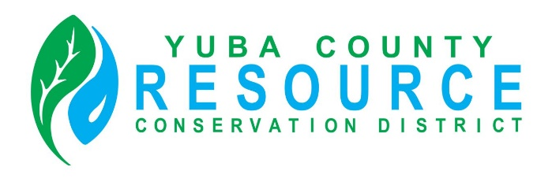

Regular Meeting of the Board of Director’s
Friday, October 10, 2025
9:30 A.M.
Yuba County Agricultural Commissioner’s Office conference room
915 8th Street, Suite 127, Marysville, California

Conference Room Directions and Participation Options

This meeting will be held in person at the Yuba County Agricultural Commissioner’s Office conference room. To reach the Agricultural Commissioner’s Office, enter the main entrance of the Yuba County Office Building, and either follow the directions provided on the signage or ask the officers at the main entrance for directions.

The public is invited to listen, observe and, at designated times, provide comments during the meeting.

For members of the public interested in viewing and having the ability to comment at the public meeting via Zoom Video Conference and Audio Teleconference, an internet enabled computer equipped with a microphone and speaker or a mobile device with a data plan is required. Use of webcam is optional. Login information is provided below.

Join Zoom Meeting
Zoom Meeting Link
Meeting ID: 401 531 1466

One tap mobile
+16694449171,,5127564528# US
+13462487799,,5127564528# US (Houston)
Phone
1 669 444 9171 US
Meeting ID: 512 756 4528

Find your local number

AGENDA

ROLL CALL

CHANGES TO AGENDA
The Board may make any necessary additions, deletions, or corrections to the agenda. This includes requesting that an item be removed from Consent or moved to another part of the agenda for discussion and separate Board action.

PUBLIC COMMENT
Opportunity for public comment on any NON-AGENDIZED items within the jurisdiction of the RCD Board. However, no action may be taken by the Board on topics of matters presented during this PUBLIC INPUT agenda item. (THE PUBLIC MUST ADDRESS THE BOARD ON SPECIFIC AGENDIZED ITEMS ONLY DURING THE BOARD’S CONSIDERATION OF THE ITEM.)

CONSENT ITEMS
The Board may approve Consent Items with a single vote. At the appropriate time as called by the Board President, members of the public may make a comment on Consent Items prior to Board action.
- Approval of the minutes of the September 12, 2025, Regular Board Meeting (either as written or as corrected).

DISCUSSION AND ACTION ITEMS
- Financial Report
  - Budget breakdown income and expenses
- Checking Account Update
  - Updated Banking Policy
  - Adoption of Resolution 2-25
- Review and approve YCRCD Order of Succession Policy
- Fiscal Year End Investment Portfolio Summary review
- Bookkeeping services discussion and action
- Review and approve of Streamline invoice for ADA compliance fees (Website)
- Review and approve of invoice/payment to Forester’s Co-Op for work performed on the Oregon House Project
- Approval of Notice of Exemption for Camptionville Project to satisfy CEQA
- Update on RCD Strategic Planning discussion and outline
- Update on YWA loan and grant application
- Discussion and potential approval of CARCD loan request.

- Executive Director Report
  - CARCD Wildfire Resilience Forestry block grant update (Oregon House)
  - CalFire Wildfire Prevention Grant update (Camptonville)
  - Summary of grant possibilities (COCO AIM)
  - Project updates
  - Other
- Upcoming Events

BOARD PRESIDENT’S REPORT

DIRECTORS’ COMMENTS AND REPORTS
- Comments and Reports
- Agenda Items for Next Board Meeting

ADJOURNMENT

