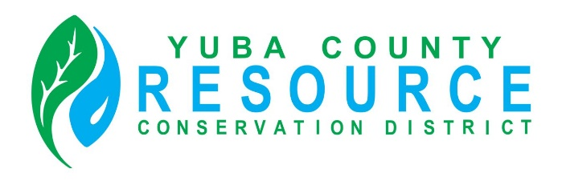

Friday, November 11, 2022
Regular Board of Director’s Meeting
Is Cancelled

Special Board of Director’s Meeting
Will Be Held
Friday, November 18, 2022
9:30 A.M.

