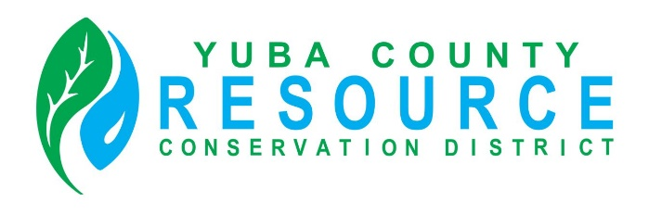

Special Board of Director’s Meeting
Scheduled for
Friday, November 18, 2022
Is Cancelled

